**VN2 Solutions Pvt. Ltd**

#### **Shared-disk Architecture:**

* Snowflake uses a **central data repository** for persisted data **accessible from all compute nodes in the platform**.
* Used in traditional databases, shared-disk architecture has one storage layer accessible by all cluster nodes.
* Multiple cluster nodes having CPU and Memory with no disk storage for themselves communicate with central storage layer to get the data and process it.
* Oracle Real Database Clusters is one such example of shared database architecture.

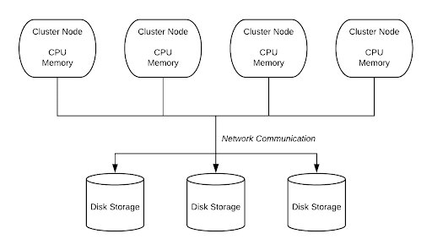

**Shared-Nothing Architecture:**

* Snowflake processes queries using virtual warehouses where each node in the cluster stores a portion of the entire data set locally.
* Shared-Nothing architecture has distributed cluster nodes along with disk storage, their own CPU, and Memory.
* The advantage here is that the data can be partitioned and stored across these cluster nodes as each cluster node has its own disk storage.
* When one of the computer nodes in a shared-nothing cluster fails, it transfers the processing rights to another node in the cluster.

. 